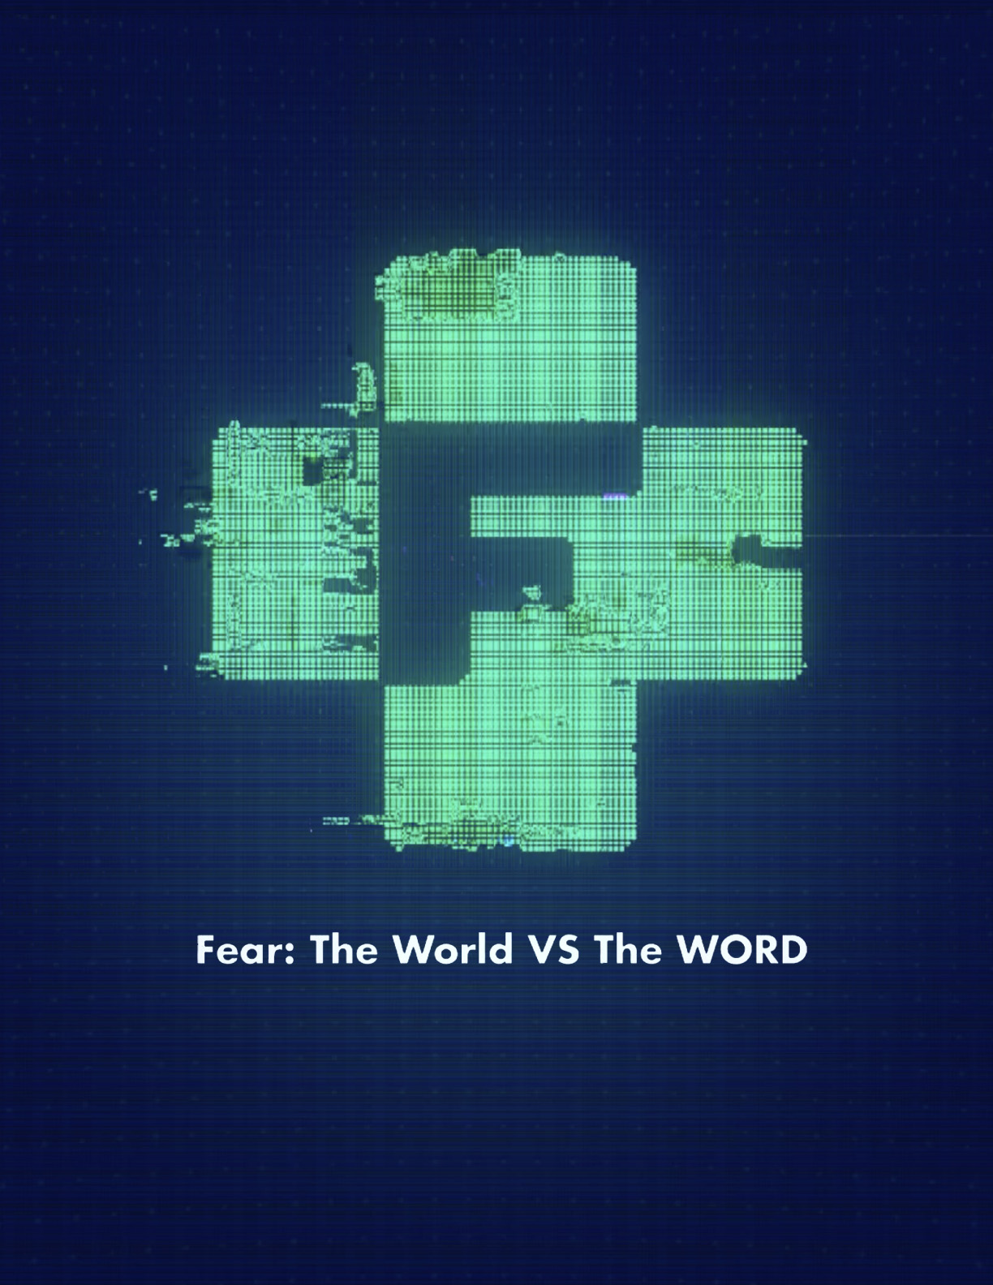

Fear: The World VS The WORD

(Note: This standalone message was created in response to the coronavirus in Spring 2020. However, it is a good baseline for any public scare that takes place, whether it be mass sickness, a natural disaster, unexpected fighting, terrorist attacks, war, etc.)

(Slide 1) The only thing to fear is fear itself... Franklin Delano Roosevelt (FDR)

(Slide 2) The current fear: Corona Virus became the COVID-19 virus named this way COrona VIrus Disease 2019

1. The fear that FDR was talking about in this quote was being afraid. The fear caused by the COVID-19 and other viruses over the years is that same kind of fear. There are multiple kinds of fear in the Bible. We will talk about those today and the differences between them. The reason there are different kinds of fear is that the language the Bible was originally written in is much larger than the English language. That is why a word such as fear can have multiple meanings. Another example of this happening throughout scripture is the word love. There are four different kinds of love in the Bible. But they are all translated as the English word and meaning of love.

(Verses on separate slides)

2 Timothy 1:7 New Living Translation (NLT)

7 For God has not given us a spirit of fear and timidity, but of power, love, and self-discipline.

2. Let's first talk about the kind of fear that FDR and the virus caused us to feel, but also see how God handles this. According to this verse, He does not want us to be afraid. In fact, the term "do not be afraid" shows up 365 times in the Bible. It's a daily reminder that we do not have to walk in the kind of fear that makes us afraid. Instead, we can walk in power, love, and self-discipline. In other words, we can walk with His power while sharing His love. It's also crucial in situations like this that we use our brain that was given to us by God. No matter how far away you feel from God remember that you are only one step away from turning to him, which is the meaning of repent, he is already making His way to you:

Psalm 34:4
God met me more than halfway, He freed me from my anxious fears.

3. Here are a couple of other verses on fear, and look at how the writer shares the difference between the world and God's Word:

Psalm 49:4-6 The Message (MSG)

3-4 I set plainspoken wisdom before you,
my heart-seasoned understandings of life.
I fine-tuned my ear to the sayings of the wise,
I solve life's riddle with the help of a harp.
5-6 So why should I fear in bad times, hemmed in by enemy malice, Shoved around by bullies, demeaned by the arrogant rich?

Proverbs 29:25
The fear of human opinion disables; trusting in God protects you from that.

4. And that takes us to the second meaning of the word fear. This is a biblical meaning of how we should fear God. It means respect. It means reverence. It means we understand the power and the love that God has, and that can live through us. Look at the following verses, the first one shared by the Y this man who ever lived, Solomon, and the second from the most quoted profit from the Old Testament, Isaiah:

Ecclesiastes 8:12-13
Even though a person sins and gets by with it hundreds of times throughout a long life, I'm still convinced that the good life is reserved for the person who fears God, who lives reverently in his presence, and that the evil person will not experience a "good" life. No matter how many days he lives, they'll all be as flat and colorless as a shadow—because he doesn't fear God.

Isaiah 41:9-10
Don't panic. I'm with you. There's no need to fear for I'm your God. I'll give you strength. I'll help you. I'll hold you steady, keep a firm grip on you.

5. ...and on top of these words, John shares with us HOW to both have the fear of God and overcome the fear of man and this world:

1 John 4:18

[ To love, to Be Loved ] God is love. When we take up permanent residence in a life of love, we live in God, and God lives in us. This way, love has the run of the house, becomes at home and mature in us, so that we're free of worry on Judgment Day—our standing in the world is identical with Christ's. There is no room in love for fear. Well-formed love banishes fear. Since fear is crippling, a fearful life—fear of death, fear of judgment—is one not yet fully formed in love.

(Second to last slide)

Fear is Liar – by Zach Williams

Fear, he is a liar
He will take your breath
Stop you in your steps
Fear he is a liar
He will rob your rest
Steal your happiness
Cast your fear in the fire
'Cause fear he is a liar

(Last slide...use YOUR fear that you are teaching on here)
The Corona Virus – or COVID-19 – we should still proceed with caution – (such as we did by meeting virtually) - but not walk with the fear of being afraid, but sharing the kind of fear that is reserved for God, through his love. When we do, people see something different in us – and it is a chance to show and share our faith.

