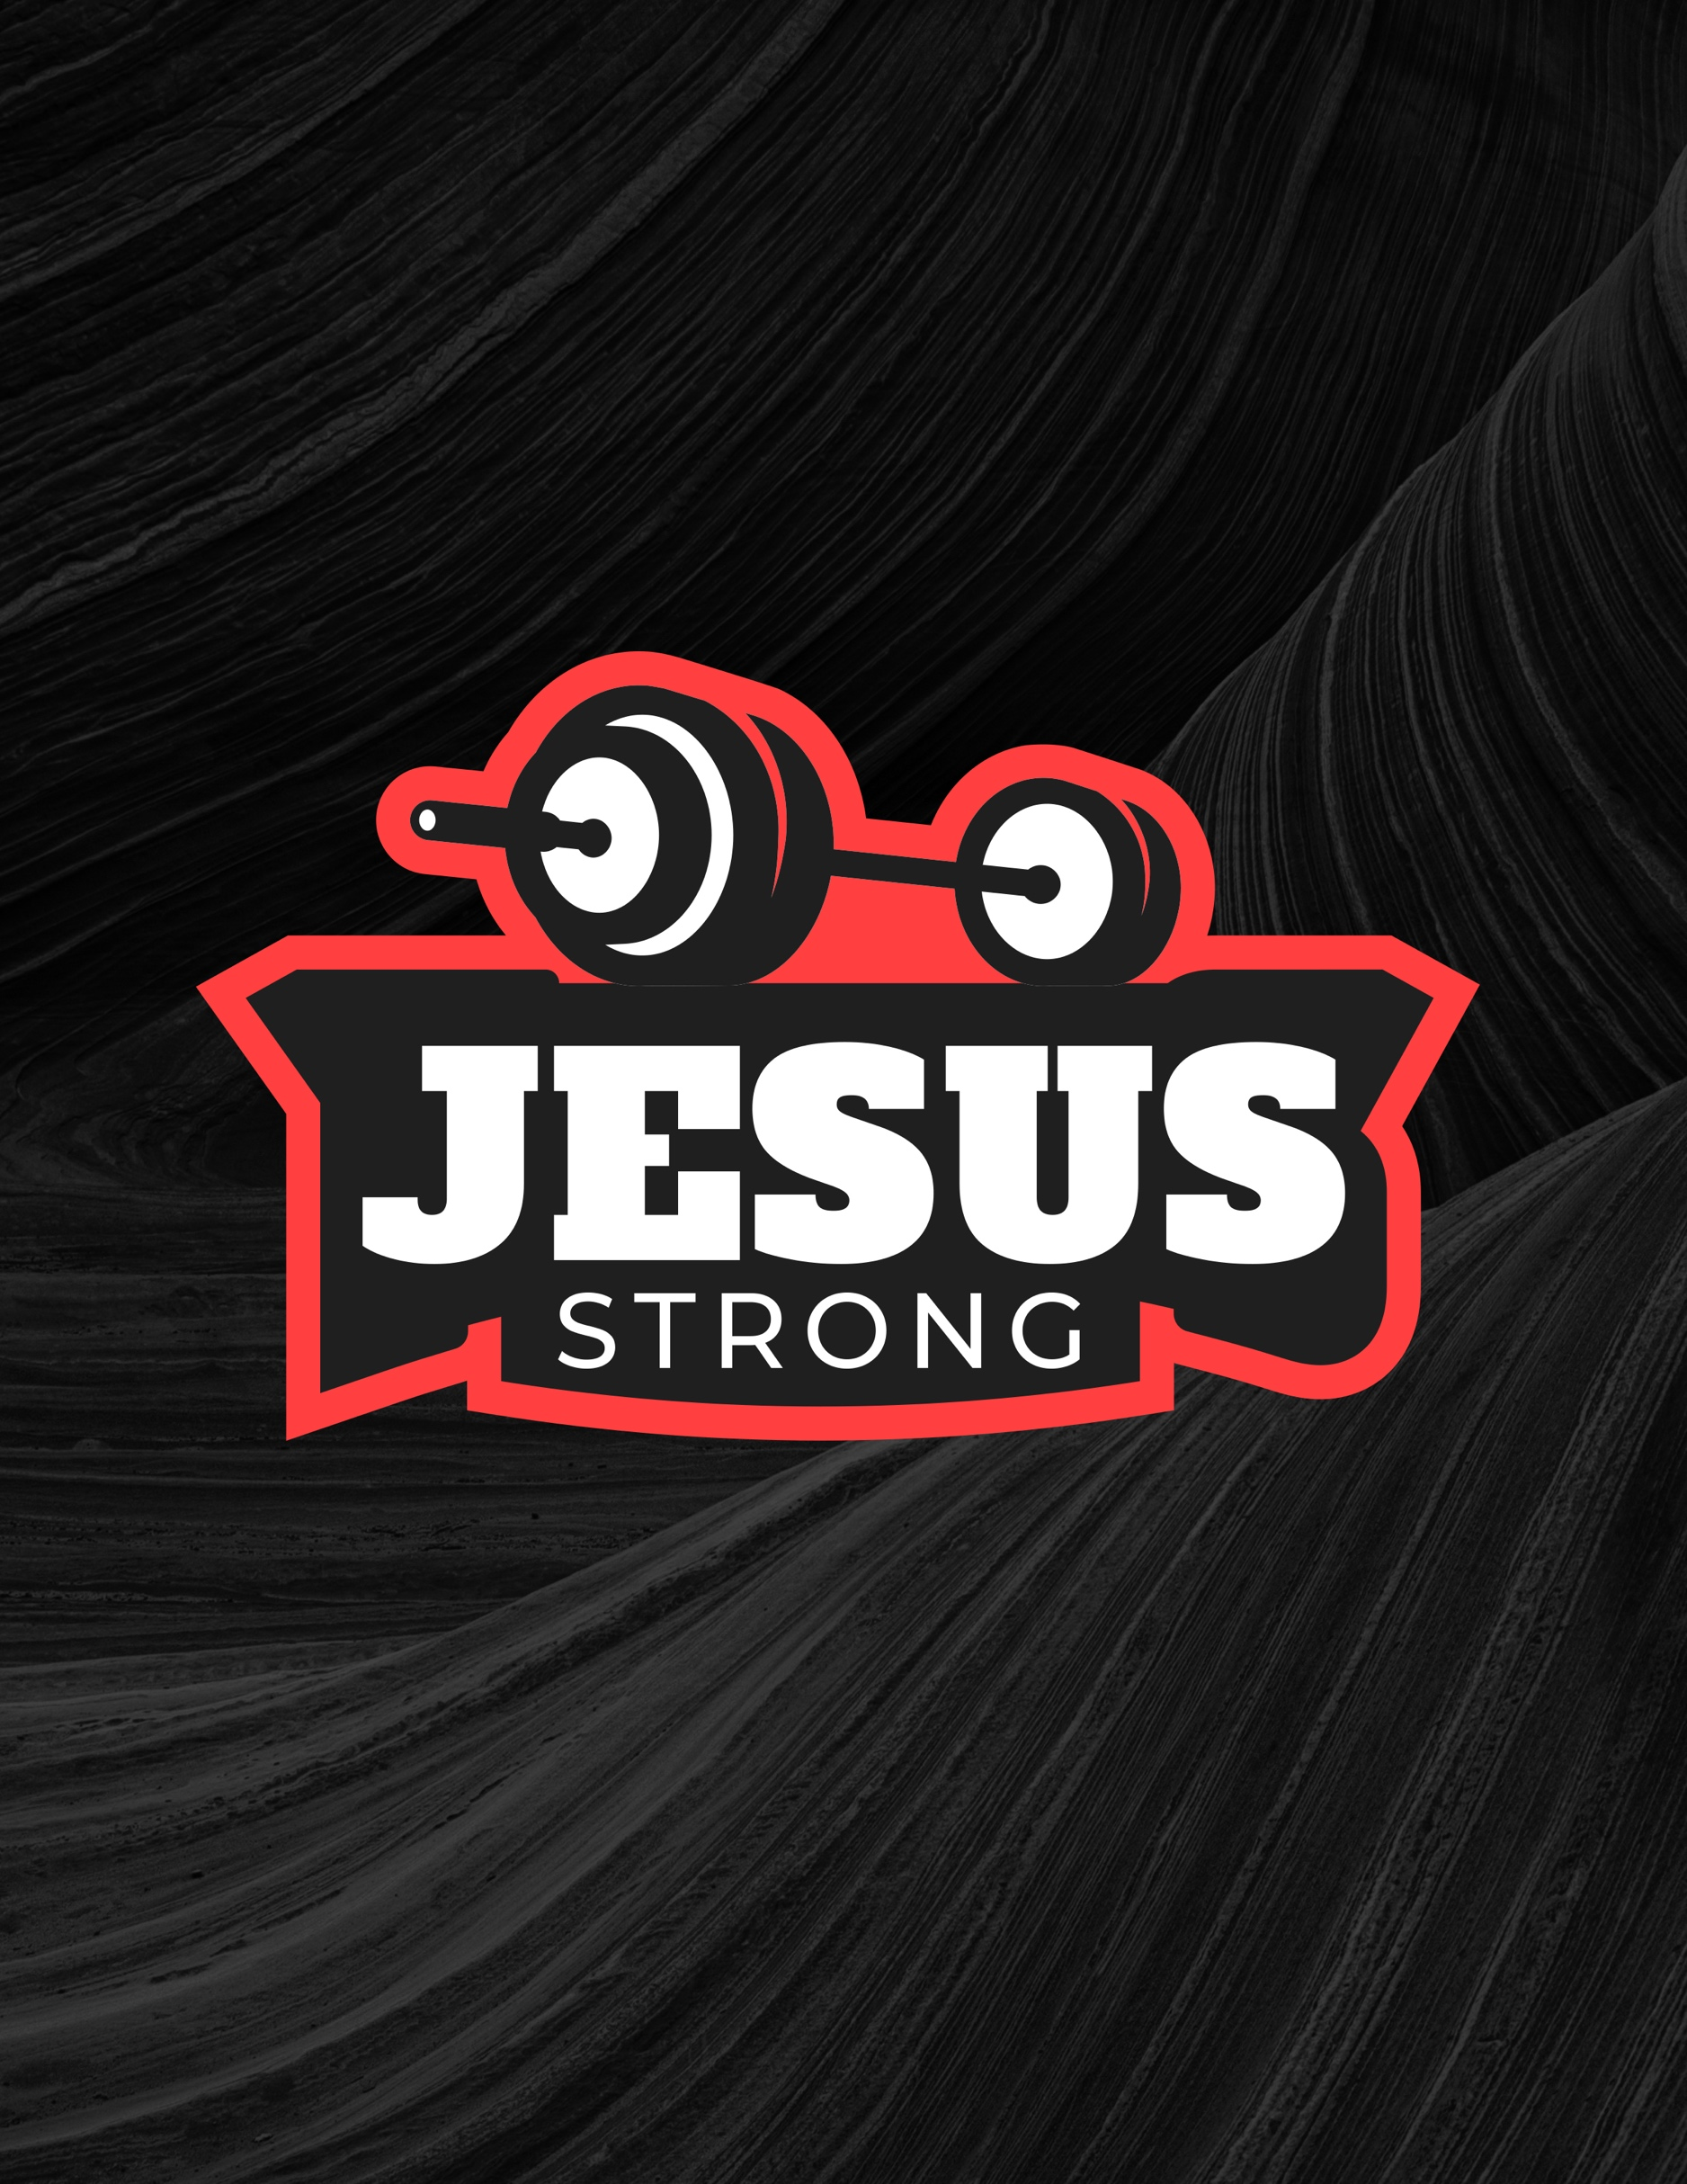

Jesus Strong: Because You are Not Strong Enough
Big Idea of the Series: This 3-week series will cover how we overcome, endure and have victory with the power of God in our lives. We will gain an understanding of our weaknesses and how God will use those to make us powerhouses in the kingdom of God.

Week 1
Text: Philippians 4:13
Topic: God’s Strength
Big Idea of the Message: We cannot do anything apart from Jesus. We are in a state of helplessness, even though we think we are in control. We must come to a place of surrender, willing to trust in the strength of our Father God.

Sermon Ideas and Talking Points:

- Christ is the Strengthener: Just about everyone would say, “You find strength in God.” That is correct because we know from Scripture what it says in Philippians 4:13: “I can do all things through Christ who strengthens me.” Every lost person has no idea what it means to abide in the power of God; right? But most Christians do not realize it either.

That is why so many Christians are miserable and full of worry, fear, doubt and dismay constantly. They are trying to change their life on their own while wearing a smile and a t-shirt that says, “I trust in Jesus”. But they have no true peace and rest in the comforting arms of Christ.

This is very important. If you are doing things and trying to overcome anything in your life, be what it may, you will fail without the strength of God to carry you through. You are not trusting God and by not trusting God you are putting more trust in you. We do not trust His wisdom; we do not trust His timing, and we do not trust His sovereignty. We can all see what’s wrong in that scenario, right?

But you will emphatically say, “I trust the Lord in everything.” Do you trust God in everything? Can you give everything over to Him so that He will work the situation out for His good and His glory, or do you get in the way when you assume you know the outcome and you might not agree with it?

Isaiah 41:10: “Fear not, for I am with you; be not dismayed, for I am your God; I will strengthen you, I will help you, and I will uphold you with my righteous right hand.”

Here is a great object lesson on God’s strength:
https://www.youtube.com/watch?v=W2y646OFlIw

- Why Do We Think God’s Strength is Not Enough? We think that we can do some things better than God our Creator. How easily we forget the words of Jesus.

Matthew 6:25-27: “Therefore I say to you, do not worry about your life, what you will eat or what you will drink; nor about your body, what you will put on. Is not life more than food and the body more than clothing? 26 Look at the birds of the air, for they neither sow nor reap nor gather into barns; yet your heavenly Father feeds them. Are you not of more value than they? 27 Which of you by worrying can add one cubit to his stature or a span to his life?”

Philippians 4:6: “Be anxious for nothing…”

We are to work out what God works into us. We can only do this when we realize that we are an empty vessel that His Spirit can fill for Jesus Christ to work through. Then the baggage, the uncertainties, the worries and the stresses that you carry and have carried around for many years; you will finally be able to let go of them. Not just the bits and pieces that you do not care about or feel that God could not handle for you.

How many times do we worry about God Almighty not being able to see us through? More times than we will ever admit! Daniel trusted and stood tall in the lion’s den. Shadrach, Meshach, and Abednego trusted, and God stood in the fire with them. David relied on God’s strength and killed a lion, a bear and a giant.

- We are Not Meant to Carry Burdens: Researchers at the University of Virginia have found that most people perceive a hill to be steeper than it really is, especially if they are tired or carrying a heavy load. When asked to estimate the slope of a hill, test participants consistently misjudged it, thinking a 10-degree slant was about 30 degrees, and rating a 5-degree slope as nearly 20 degrees. Hardly any of them believed they could be that far off.
When we are burdened and exhausted, even a very minor problem can seem too big for us to handle. As we encounter a test in life, we are tempted to sit down at the base of that tough hill and stay right there, convinced that the grade is too steep for us and we could never conquer it. That is why we need the strength of the Holy Spirit and the encouragement of God’s Word.
“He gives power to the weak, and to those who have no might – He increases strength” (Isaiah 40:29).
Message LifePoint: Many of you are doing the exact same thing with issues in your life right now. It all comes down to a trust factor with God. God allows trials in our lives to show that at our weakest points, the strength and comfort of Christ will be the strongest. When we feel strongest in our own strength is when we have or will have the greatest failures. Because if God is not in it, then it is not going to prosper.
What did Jesus tell us in Matthew 11:28? “Come to me, all who labor and are heavy laden, and I will give you rest.”

Jesus Strong: Because You are Not Strong Enough

Week 2
Text: 2 Corinthians 12:9-10
Topic: Our Weakness & God’s Strength
Big Idea of the Message: God’s grace is always sufficient because He is all powerful and His grace is everlasting. Nothing can match God’s power.

Sermon Ideas and Talking Points:

- Sufficiency of His Grace: 2 Corinthians 12:9-10: “And He said to me, “My grace is sufficient for you, for My strength is made perfect in weakness.” Therefore, most gladly I will rather boast in my infirmities, that the power of Christ may rest upon me. Therefore, I take pleasure in infirmities, in reproaches, in needs, in persecutions, in distresses, for Christ’s sake. For when I am weak, then I am strong.”

Ponder that for a moment and really let it sink in. Do you have fears, inhibitions, worry, stress and doubt? These things are not the causes; they are the outcomes when you try doing things in your own power. You are not relying on God in these affected areas of your life. Joy, peace, love and a viewpoint in God’s eternal glory come when you put your full trust in Him and let the strength of our great God lift you up. It must be full trust in everything in your life; everything. No matter how difficult and trying as it may be.

Do we not serve a God who knows all our unknowns? We serve a sovereign God who is omniscient - He knows all and works all things together for good to those who love Him. What do we have to fear?

Isaiah 26:4: “Trust in the Lord forever, for the Lord God is an everlasting rock.” Isaiah 40:31: “But they who wait for the Lord shall renew their strength; they shall mount up with wings like eagles; they shall run and not be weary; they shall walk and not faint.”

- We Have to Push Ourselves Aside: Gideon was afraid. He questioned God; he even hid in a winepress when God asked him to save the Israelites. But God turned his fear and anxiety into courage and might. He does the same for us when realize the power of the Holy Spirit in our lives.
It is when we lose ourselves, or basically get over ourselves that God can shine through us; then we will do things that many will remember. We are to bear good fruit. But the tree does not grow in a day.

An apple tree takes 4-6 years from a seed to full maturity to produce fruit. But even a full-grown apple tree, if not properly cared for and nourished can give bad or diseased fruit. The same holds true for us. Are we trying to nurture and grow ourselves in our own power or are we letting the Holy Spirit provide the increase in us?

Jeremiah 17:5-6: “Thus says the Lord: “Cursed is the man who trusts in man and makes flesh his strength, whose heart departs from the Lord. For he shall be like a shrub in the desert, and shall not see when good comes, but shall inhabit the parched places in the wilderness, in a salt land which is not inhabited.” What is being fed to your spirit? What fruit are you producing?

Philippians 2:13: “For it is God who works in you, both to will and to work for His good pleasure.” This is the truth of all of this in our lives. You must get out of the way and push yourself down so that the Holy Spirit can be raised up to feed you. Then God will produce good fruit by Him, through you, for His glory. “I can do all things through Christ who strengthens me”. I can do nothing unless it is THROUGH Christ who strengthens me.

- You Actually Grow Weaker When You Do it on Your Own: When you were or are in trials, anxiety was your best friend and may be so right now. Is it doubt that stares you in the face in the morning mirror? Or do you rise with a song of God in your heart knowing that whatever the day, the year, whatever your life may bring only comes within the boundaries that the Sovereign God of all allows it to go?

Joshua 1:9: “Have I not commanded you? Be strong and courageous. Do not be frightened, and do not be dismayed, for the Lord your God is with you wherever you go.” Isaiah 12:2: “Behold, God is my salvation; I will trust, and will not be afraid; for the Lord God is my strength and my song, and he has become my salvation.”

The Apostle Paul acknowledged all the troubles he faced in life (but did so to boast in the cross), but he says that the Lord rescued him in all of them. Despite what you’re going through, if you hold on to God and His Word, He will save you. Paul came face to face with death many times but had peace because he knew that he has a crown of righteousness waiting on him. He didn’t give up his “good fight of faith” for the Lord because he knew that God’s grace was always and the only sufficiency to his life.

Message LifePoint: Paul realized what we all must truly acknowledge; suffering and trials are ALL temporary. They will and do come to an end. What does not end is the glory and love of God for you. That remains for eternity.

Psalm 118:6: “The Lord is on my side; I will not fear. What can man do to me?

You cannot gain any of this if you are looking to self-help anything. You cannot look inside yourself to find strength and inner peace. Only God can give you the means to be born again and to become spotless. Belief in Christ will cause the indwelling of the Holy Spirit and then you can become cleansed, justified and born again – by His strength!

Jesus Strong: Because You are Not Strong Enough

Week 3 - Conclusion
Text: Luke 10:27
Topic: God’s Strength
Big Idea of the Message: What happens to us when God’s strength is placed in us? How does that change every aspect of our life?

Sermon Ideas and Talking Points:

- Seek Virtue over Vice: We seek every avenue and vice to bring fulfillment and joy to our lives and we do nothing but put ourselves in God’s permissive will. When we do this, we are like hamsters that run on a wheel. We waste all our time, energy and resources. When we get off that wheel, what do we find? We are still in the exact same place that we were when we started running. Isaiah 30:1: “Woe to the rebellious children,” says the Lord, “Who take counsel, but not of Me, and who devise plans, but not of My Spirit, that they may add sin to sin; All of us, especially when we are younger, all have this grand plan for our lives. Our lives go on as we planned without a hitch, right? Absolutely not.

Many have been deemed successful by the worlds standards and what did they have to show for it when they died? Absolutely nothing because they refused God and will spend eternity in Hell. Our lives are not measured by what we have done. Our lives are measured by who we are and what we have done in Christ. Would good does it do to be the richest person in the grave? For most people their vice is not a physical one, but a belief in their own strength.

Example: A college student was in a philosophy class which discussed God's existence. The professor presented the following logic: "Has anyone in this class heard God?" No one spoke. "Has anyone in this class touched God?" Again, nobody spoke. "Has anyone in this class seen God?" When no one spoke for the third time, he simply stated, "Then there is no God."
One student thought for a second, and then asked for permission to reply. Curious to hear this bold student's response, the professor granted it, and the student stood up and asked the following questions of his classmates: "Has anyone in this class heard our professor's brain?" Silence.
"Has anyone in this class touched our professor's brain?" Absolute silence.
"Has anyone in this class seen our professor's brain?" When nobody in the class dared to speak, the student concluded, "Then, according to our professor's logic, it must be true that our professor has no brain!"
(...The student received an "A" in the class.) – Author unknown

Self-belief, self-esteem, self-reliance and self-strength is the opposite of faith. We all want to know everything about everything. But that is not life and it shows that we are not God because we do not know everything. Trusting on God to guide your life and totally resting in Him does not mean that you will have clarity. People seek clarity. Clarity does not bring purpose in God’s perfect will. Faith does. You must have so much faith in God that you can jump into the volcano of life trusting that He will spare you even though the trials may burn you at times. You must trust that His strength will pull you through no matter how severe the test may seem to you.

- It is More than You Can Handle: You hear people say that God will not give you more than you can handle. I do not agree with that. I believe that at times God will give you more than you can handle, and you have no choice but to turn to Him because nothing or no one can get you through; except for Him.

"The Scripture shows that God led Israel to the driest place in the whole wilderness — no stream, no well, not a trickle of water — where He allowed them to grow thirsty. The people complained to Moses, but God had a plan!" - David Wilkerson

Message LifePoint: You only grow spiritually when you truly let go, asking God to take it for you. Jesus asked for us to give Him our burdens, but we want to hold on to them. Why? Is it fear, uncertainties, lack of trust in the Savior to get us through; or all the above?
You must understand that the mountains, the wilderness, path or storm ravaged sea before us all bow down to Him.

Jesus Christ is the strongest man spiritually and mentally that ever walked this earth. We would all agree on this; right? But where did He seek strength? Not from Himself, but the Holy Spirit sustained Him. He sought God in everything. Jesus trusted the full weight of God’s mighty hand at the beginning of His life and ministry all the way to His crucifixion upon the cross.

God prepared Him by His power so that Jesus could endure. If Jesus, our example and our beautiful Savior, sought God and His strength in everything than why aren’t we? We put our trust in Him to save us for eternity and to take us to heaven to be with Him, but we do not have the trust to believe He will help us in any situation in the full scope of our life?

Trust God and rest in His arms. Because we so easily misjudge life’s difficulties, we need courage to keep going when we are tempted to quit. In His strength, you can conquer any difficult hill. I can do all things through Christ who strengthens me. Not around, above, or under. Only through; all things must pass through our Savior and His ultimate strength.

