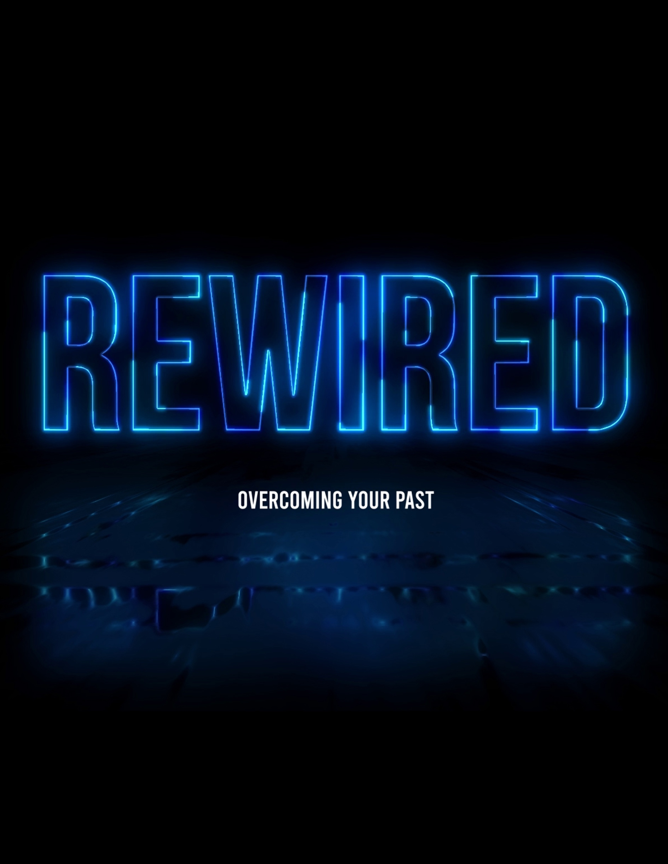

Your Past is No Excuse: Forget Your Past and Press On
Big Idea of the Series: This 2-week (can be stretched to 3) series will cover how the Bible sees our past once we become saved by Christ. This world defines us by our past, but God does not. How do we leave all that baggage, our wounds and faults behind us?

Week 1
Text: 1 Corinthians 7:20-24 & Philippians 3:13-14
Topic: Leaving the Past Behind
Big Idea of the Message: Who are we in Christ and what does that mean for our past and our future?

Sermon Ideas and Talking Points:

- Your Past Does NOT Disqualify You: (see 1 Corinthians 7:20-24)

Your past or even your present circumstances are no excuse or disqualification to serve God. The Bible has an ample list of fallen people who had pretty sketchy pasts but were redeemed. They had faith in and a repentant heart for God; and God in His gracious sovereignty used them for His purpose and will. As He will you when you truly give your life to Him. Because saying “I gave my life to Christ” is one thing but saying “I am picking up my cross daily for Jesus” is another entirely.

When God calls you, obey the will of God no matter what your life has amounted to thus far. We all fall short, but do not limit what God can do with you for His ambition and His glory. Even if you have had a life of vicious circles of repetitive failures trying to do things in your own strength. The thief on the cross was a believer and follower of Jesus for only a few hours of his life before he died, and Jesus told him, “Today you will be with Me in Paradise.” – Luke 23:43. The Lord erased his past because of his faith in Jesus that secured his future.

Story: “Back in 2000, 23-year-old Cornealious Anderson III, nicknamed Mike, was arrested for robbing a Burger King at gunpoint. He was sentenced to 13 years in prison, released on bail, and told to await orders on when to show up to serve his time. The orders never came. Due to a clerical error, Anderson never went to prison. But instead of using his freedom to commit more crimes, Anderson started his own construction business, became a youth football coach, and volunteered at his local church. He also got married, had three children, and became a well-liked member of his community. Thirteen years later, the state discovered their error and put Anderson behind bars for nearly one year. As the case received international coverage, an online petition for his release gained more than 35,000 signatures. After a court hearing that lasted a mere 10 minutes, the judge conceded that Anderson was a changed man and granted him credit for the years he should have been in prison. A teary-eyed Anderson walked out of the courthouse with his wife and daughter, telling reporters that he was ‘grateful to God.’”

No matter how hard we strive to do things without Him, Jesus is always right behind us, waiting with open arms. Your past is nothing but; it is past. It is gone.

- God Will Take the Bad in the Past and Use it for Future Good:

Why? To glorify Him and to use us to help others in our present and our future. That is why intimacy and abidance in God’s will is so essential in our Christian walk with Jesus. Philippians 3:13-14: ... “But one thing I do: forgetting what lies behind and straining forward to what lies ahead, I press on toward the goal for the prize of the upward call of God in Christ Jesus.”
What are you holding onto and harboring in your life? If someone has hurt you in the past, God will ease that agony once you truly forgive that person for what they have done. Well, you might say, “I cannot forgive them, or I will never forgive them”. Why not? Jesus forgave all of us who put Him to death for our sins against Almighty God.

You cannot change the former days and nothing in the past now matters. What you are doing for the cause of Christ is what matters now. Ephesians 4:22: “(You are) to put off your old self, which belongs to your former manner of life and is corrupt through deceitful desires…”

It is said that “The past is a point of reference and not a destination.” Very true but so many want to live there. As the movie in the song “Frozen” says, “Let it go, let it go.” You want to help someone struggling? Witness to them what God did with your past and is now doing for your future.

Jesus told us to come to Him as “little children”. A man once had a dream that he was climbing this beautiful white and gold staircase which ended at the Throne of God. The higher up the staircase the man climbed, the higher each step got. When he reached the top, he was no longer an adult but a child who climbed into the lap of God the Father.

- To Love God and Love Our Neighbors Takes Present Action: How do we do this if we are clinging to unforgiveness or sins of the past that we refuse to let go of? We cannot. We cannot truly love unless we give these things over to God. 1 John 2:1-2: “My little children, I am writing these things to you so that you may not sin. But if anyone does sin, we have an advocate with the Father, Jesus Christ the Righteous. He is the propitiation for our sins, and not for ours only but also for the sins of the whole world.”

“The Christian life is like a fish swimming upstream, going against the currents of the world, the flesh and the devil. Your struggle to honor Christ in all these things is the evidence that you are going in the right direction.” (Colin Smith). Can you drive your car forward if you are looking in reverse? Or vice-versa. The best thing for you to do is to rip off the rear-view mirror of your life and look at the road before you. God forgave you, forgive yourself. Forgive it and let go. Forgive it and move on. Why drag it along on the road of life with you? You can never take a step forward to what God has called you for if you refuse to stay put in your past. The past is already what it says – it is PAST! You can never go back no matter how hard you try.

Message LifePoint: Our past brings scars. We all have scars. Whether visible, invisible or both. We should thank Jesus for those scars. Why? Because by His wounds our past wounds have been healed and the scars show the healing grace of His love. Clay cannot be fashioned until it is a lumped mess on the Potter’s table.

Your Past is No Excuse: Forget Your Past and Press On

Week 2 - Conclusion
Text: Ephesians 2:1-10
Topic: Leaving the Past Behind
Big Idea of the Message: Seeing who we are as a new creation in Jesus Christ. Our old self has died, and we are made new in Him. How do we function, worship and live in a new creation life?

Sermon Ideas and Talking Points:

- Deny Yourself of the Past: Deny yourself. Deny yourself. Denying ourselves is the toughest thing for human beings to do. Sin turns your own body and mind against you. Most people in the world make the devil’s job easy. Deny yourself and fully give into the will of God for your life. If you try to deny yourself but still cringe or say “God, OK but I still need this or I still want to do that in my life”, that is not full compliance to God's purpose for you. You are not denying yourself.

“Believe it or not, it’s easier to deny yourself by giving up things such as chocolate or social media than it is to deny yourself by considering others’ interests a priority before your own. We want things such as the front of the line, the best movie seats, the quickest exit. We pursue those things out of reflex. If we want to deny ourselves and enjoy the sweet spot of following Jesus, we need to re-train our thinking and our behavior.” – B. Shafer

When you repent, fully yield to the Holy Spirit and give it all over to Him that is when you have a spiritual breakthrough. You produce good works for God, and you become what you were meant to be; a selfless servant to be used by God and for God for His glory. Our meaning in life is to be a vessel for God’s Holy Spirit to show Jesus Christ’s love to everyone. Works done for you or thinking that you gain heaven by them are meaningless because faith in Christ is the only way to heaven. For all of those out there who believe that all roads lead to heaven; they are on the road that doesn't. Including those who want to take the road back to their past. Quit reminiscing about the “Glory Days” and look forward to the days of glory!

- We Cannot Make Up for Our Past: So, stop trying…because a salvation by works attitude devastates the gift of grace. We must obey first and then God reveals to us what He wants us to do. He expects submission and then He expects us to do what He tells us to do. We are to fulfill His will for us in our lives. Then, we must extend and share that same grace, forgiveness and love to others that has been graciously shown to us. Then we are doing good and faithful works for Christ. It all must point to God.

Very good object lesson about letting go can be found here:
https://www.patreon.com/posts/20351370

- You Past is Outside of God’s Will for You: There is no comfort or contentment outside of God's will. None. Nothing fills the emptiness that is inside of us except for the Holy Spirit. Why do we prefer to stand in the past wasteland when we have been granted permission to stand in the Holy of Holies? “Romans 8:1: There is therefore now no condemnation for those who are in Christ Jesus.” You are no longer convicted. When you forgive, when you repent of all your sin; that is when you can have a clear conscience and find true joy and freedom in Jesus Christ.

When you are lost, the world will feel like it is falling all around you. Being saved by Christ you need to see it in a different light. The world is no longer falling around you; it is you breaking free from the past world and the pieces of it are falling off you as you ascend closer each day toward heaven.

2 Corinthians 9:15: “Thanks be to God for His indescribable gift!” That gift is the Holy Spirit of God and only by faith in Him do we go to heaven. Many people diligently and faithfully plant seeds in their gardens and their fields (for some it is their livelihood), but how many of us have that same urgency planting seeds for Jesus? Is that not of more importance? It takes a Kingdom of God mindset and not your crumbled kingdom of the past. “Yesterday is history, tomorrow is a mystery, today is a gift of God, which is why we call it the present.” ― Bill Keane

Message LifePoint: Galatians 2:20: I have been crucified with Christ. It is no longer I who live, but Christ who lives in me. And the life I now live in the flesh I live by faith in the Son of God, who loved me and gave himself for me.” “2 Corinthians 5:17: Therefore, if anyone is in Christ, he is a new creation. The old has passed away; behold, the new has come.”

Picture a place that you have wanted to visit your entire life but just did not have the means to do so. But, then one day, someone shows up on your doorstep and says they will take you there, free of charge, all you must do is except that gift. They tell you they will be back soon to take you, but you do not know the exact time. Imagine your joy and anticipation! You will make sure that you are fully prepared, have everything in order and make sure that you strive to do everything correctly. You will always be ready!

You will also tell everyone you know, blow up Facebook, Twitter and Instagram about this gift! We must treat the gift of salvation and the return of our Lord to take us home with a greater respect, willingness and anticipation! But we cannot look to our destination in Heaven if we keep residing in the dwelling of our past. Let it go and press on!

